**Exp 3**

**Using any data apply the concept of: Gradient decent**

<https://www.geeksforgeeks.org/how-to-implement-a-gradient-descent-in-python-to-find-a-local-minimum/>

Gradient Descent is an iterative algorithm that is used to minimize a function by finding the optimal parameters. Gradient Descent can be applied to any dimension function i.e. 1-D, 2-D, 3-D.

We will be working on finding global minima for parabolic function (2-D). To implement a gradient descent algorithm, we require a **cost function** that needs to be minimized, the number of **iterations**, a **learning rate** to determine the step size at each iteration while moving towards the minimum, partial derivatives for **weight & bias** to update the parameters at each iteration, and a prediction function.

Let us consider a parabolic equation y=4x2. By looking at the equation we can identify that the parabolic function is minimum at x = 0 i.e. at x=0, y=0. Therefore x=0 is the local minima of the parabolic function y=4x2. Now let us see the algorithm for gradient descent and how we can obtain the local minima by applying gradient descent:

**Algorithm for Gradient Descent**

Gradient Ascent is the procedure for approaching a local maximum of a function by taking steps proportional to the positive of the gradient (moving towards the gradient).

**Step 1:** Initializing all the necessary parameters and deriving the gradient function for the parabolic equation 4x2. The derivative of x2 is 2x, so the derivative of the parabolic equation 4x2 will be 8x.

x0 = 3 (random initialization of x)

learning_rate = 0.01 (to determine the step size while moving towards local minima)



Step 2: Let us perform 3 iterations of gradient descent: For each iteration keep on updating the value of x based on the gradient descent formula.

Iteration 1:

x1 = x0 - (learning_rate * gradient)

x1 = 3 - (0.01 * (8 * 3))

x1 = 3 - 0.24

x1 = 2.76

Iteration 2:

x2 = x1 - (learning_rate * gradient)

x2 = 2.76 - (0.01 * (8 * 2.76))

x2 = 2.76 - 0.2208

x2 = 2.5392

Iteration 3:

x3 = x2 - (learning_rate * gradient)

x3 = 2.5392 - (0.01 * (8 * 2.5392))

x3 = 2.5392 - 0.203136

x3 = 2.3360

From the above three iterations of gradient descent, we can notice that the value of x is decreasing iteration by iteration and will slowly converge to 0 (local minima) by running the gradient descent for more iterations. Now you might have a question, for how many iterations we should run gradient descent?

We can set a stopping threshold i.e. when the difference between the previous and the present value of x becomes less than the stopping threshold we stop the iterations. When it comes to the implementation of gradient descent for machine learning algorithms and deep learning algorithms we try to minimize the cost function in the algorithms using gradient descent. Now that we are clear with the gradient descent’s internal working, let us look into the python implementation of gradient descent where we will be minimizing the cost function of the linear regression algorithm and finding the best fit line. In our case the parameters are below mentioned:

**Prediction Function**

The prediction function for the linear regression algorithm is a linear equation given by y=wx+b.

prediction_function (y) = (w * x) + b

Here, x is the independent variable

y is the dependent variable

w is the weight associated with input variable

b is the bias

**Cost Function**

The cost function is used to calculate the loss based on the predictions made. In linear regression, we use mean squared error to calculate the loss. Mean Squared Error is the sum of the squared differences between the actual and predicted values.

Cost Function (J) =



Here, n is the number of samples

**Partial Derivatives (Gradients)**

Calculating the partial derivatives for weight and bias using the cost function. We get:

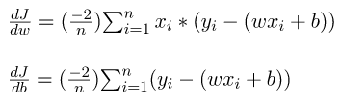

**Parameter Updation**

Updating the weight and bias by subtracting the multiplication of learning rates and their respective gradients.

w = w - (learning_rate * (dJ/dw))

b = b - (learning_rate * (dJ/db))

Python Implementation for Gradient Descent

In the implementation part, we will be writing two functions, one will be the cost functions that take the actual output and the predicted output as input and returns the loss, the second will be the actual gradient descent function which takes the independent variable, target variable as input and finds the best fit line using gradient descent algorithm. The iterations, learning_rate, and stopping threshold are the tuning parameters for the gradient descent algorithm and can be tuned by the user.

In the **main function**, we will be initializing linearly related random data and applying the gradient descent algorithm on the data to find the best fit line.

The optimal weight and bias found by using the gradient descent algorithm are later used to plot the best fit line in the main function.

The iterations specify the number of times the update of parameters must be done, the stopping threshold is the minimum change of loss between two successive iterations to stop the gradient descent algorithm.

# Importing Libraries

import numpy as np

import matplotlib.pyplot as plt

def mean_squared_error(y_true, y_predicted):

# Calculating the loss or cost

cost = np.sum((y_true-y_predicted)**2) / len(y_true)

return cost

# Gradient Descent Function

# Here iterations, learning_rate, stopping_threshold

# are hyperparameters that can be tuned

def gradient_descent(x, y, iterations = 1000, learning_rate = 0.0001,

stopping_threshold = 1e-6):

# Initializing weight, bias, learning rate and iterations

current_weight = 0.1

current_bias = 0.01

iterations = iterations

learning_rate = learning_rate

n = float(len(x))

costs = []

weights = []

previous_cost = None

# Estimation of optimal parameters

for i in range(iterations):

# Making predictions

y_predicted = (current_weight * x) + current_bias

# Calculating the current cost

current_cost = mean_squared_error(y, y_predicted)

# If the change in cost is less than or equal to

# stopping_threshold we stop the gradient descent

if previous_cost and abs(previous_cost-current_cost)<=stopping_threshold:

break

previous_cost = current_cost

costs.append(current_cost)

weights.append(current_weight)

# Calculating the gradients

weight_derivative = -(2/n) * sum(x * (y-y_predicted))

bias_derivative = -(2/n) * sum(y-y_predicted)

# Updating weights and bias

current_weight = current_weight - (learning_rate * weight_derivative)

current_bias = current_bias - (learning_rate * bias_derivative)

# Printing the parameters for each 1000th iteration

print(f"Iteration {i+1}: Cost {current_cost}, Weight \

{current_weight}, Bias {current_bias}")

# Visualizing the weights and cost at for all iterations

plt.figure(figsize = (8,6))

plt.plot(weights, costs)

plt.scatter(weights, costs, marker='o', color='red')

plt.title("Cost vs Weights")

plt.ylabel("Cost")

plt.xlabel("Weight")

plt.show()

return current_weight, current_bias

def main():

# Data

X = np.array([32.50234527, 53.42680403, 61.53035803, 47.47563963, 59.81320787,

55.14218841, 52.21179669, 39.29956669, 48.10504169, 52.55001444,

45.41973014, 54.35163488, 44.1640495 , 58.16847072, 56.72720806,

48.95588857, 44.68719623, 60.29732685, 45.61864377, 38.81681754])

Y = np.array([31.70700585, 68.77759598, 62.5623823 , 71.54663223, 87.23092513,

78.21151827, 79.64197305, 59.17148932, 75.3312423 , 71.30087989,

55.16567715, 82.47884676, 62.00892325, 75.39287043, 81.43619216,

60.72360244, 82.89250373, 97.37989686, 48.84715332, 56.87721319])

# Estimating weight and bias using gradient descent

estimated_weight, estimated_bias = gradient_descent(X, Y, iterations=2000)

print(f"Estimated Weight: {estimated_weight}\nEstimated Bias: {estimated_bias}")

# Making predictions using estimated parameters

Y_pred = estimated_weight*X + estimated_bias

# Plotting the regression line

plt.figure(figsize = (8,6))

plt.scatter(X, Y, marker='o', color='red')

plt.plot([min(X), max(X)], [min(Y_pred), max(Y_pred)], color='blue',markerfacecolor='red',

markersize=10,linestyle='dashed')

plt.xlabel("X")

plt.ylabel("Y")

plt.show()

if __name__=="__main__":

main()

**Output:**

*Iteration 1: Cost 4352.088931274409, Weight 0.7593291142562117, Bias 0.02288558130709*

*----------*

*----------*

*Iteration 17: Cost 98.63831622628217, Weight 1.389738813163012, Bias 0.03509461674147458*

*Estimated Weight: 1.389738813163012*

*Estimated Bias: 0.03509461674147458*

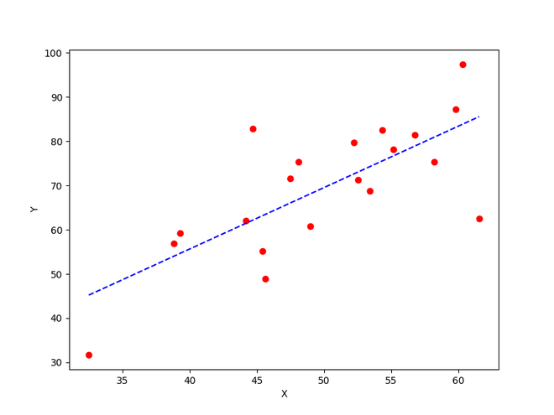

The best fit line obtained using gradient descent

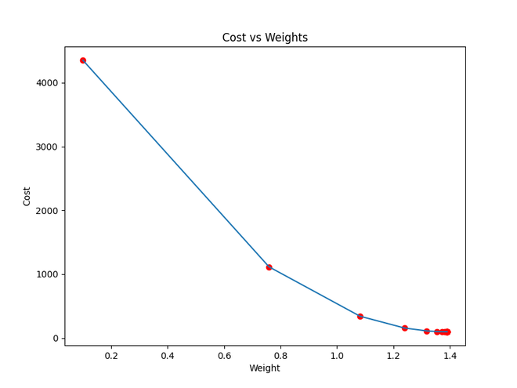

Cost function approaching local minima